ETHICAL SOFTWARE Community
Fedora Server

Table of contents

Fedora Server Basic 1
Installing Fedora Server With Gnome Desktop 2
(P.S. USB Boot Loader worked as a means for burning the ISO file to your USB) 2
SSH 20
Enabling SSH in Fedora Server 21

Fedora Server Basic

Installing Fedora Server With Gnome Desktop
Step 1. First and foremost, In order to install Fedora Server, you need the following devices;
- Formatted USB Flash Drive (No Data Inside)
- Desktop/Laptop (Windows Pre-Installed)
Step 2. Follow the step accordingly for installing the USB boot loader!
We won’t need to download an ISO file since the Fedora Media Writer will help with it.

(P.S. USB Boot Loader worked as a means for burning the ISO file to your USB)
- go ahead and download Fedora Media Writer from the URL below (Select your OS: Windows Icon).
https://getfedora.org/fmw/FedoraMediaWriter-win32-latest.exe
- Double Click the download file and Click Yes if they ask permission to write on your device.
- Agree on the terms and continue the installation.

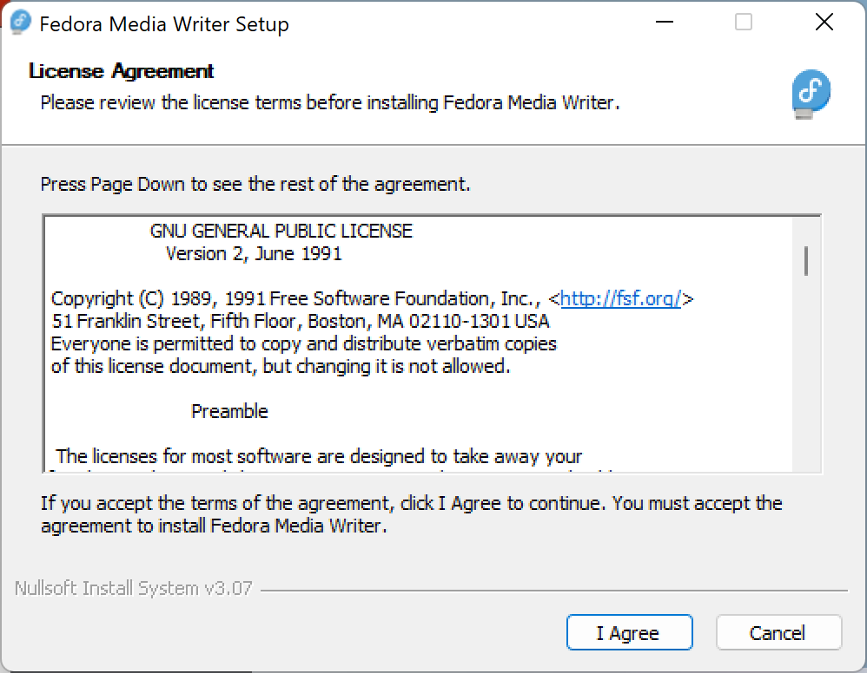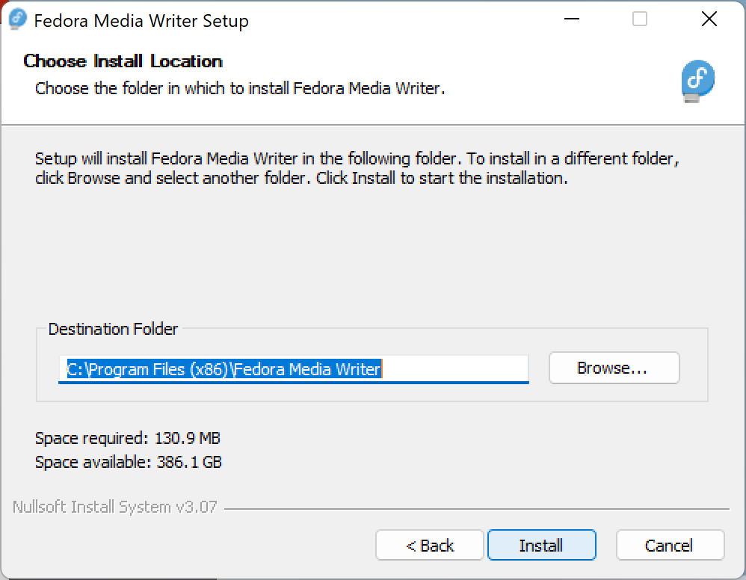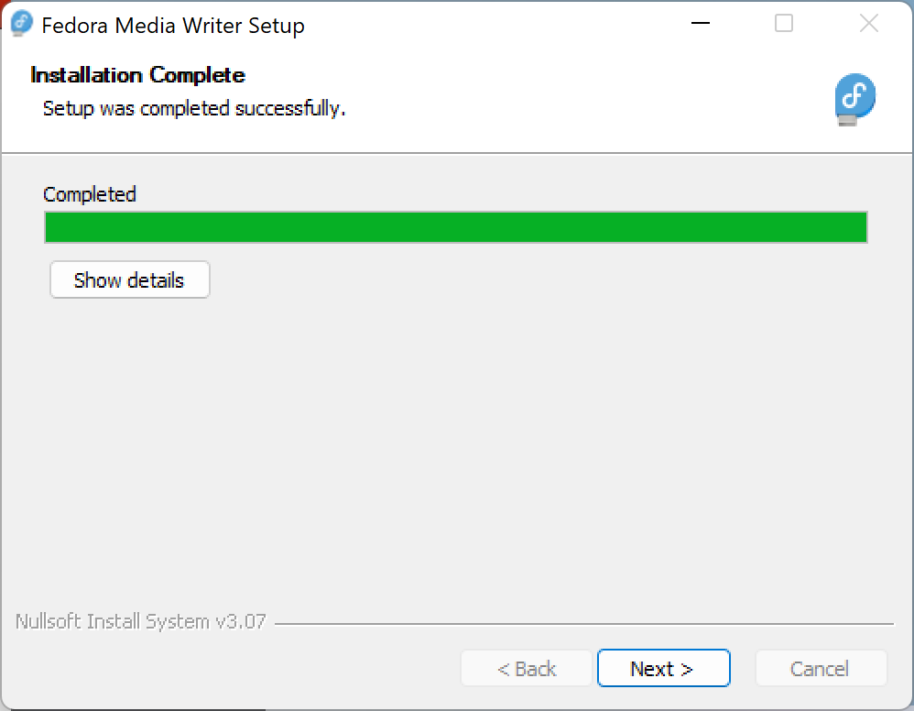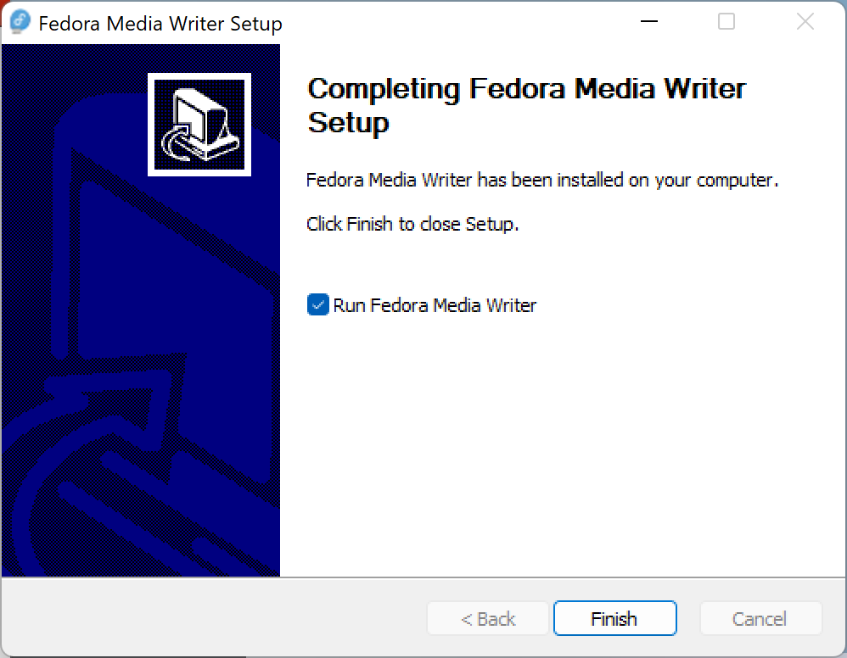
- Click on the “Next” button.

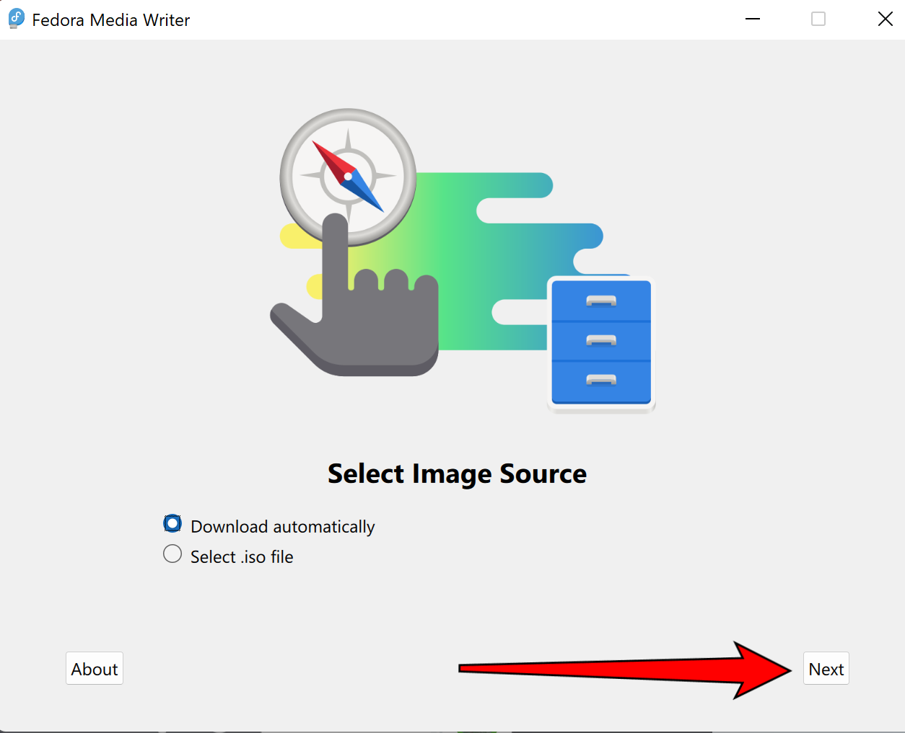
- select Fedora Server and Click Next
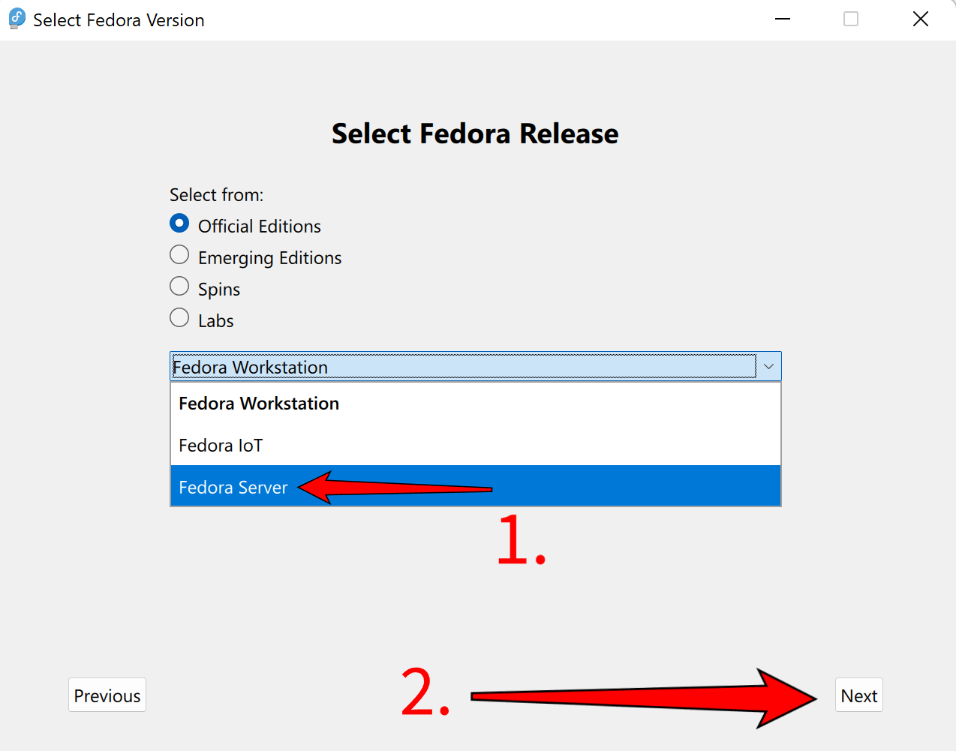
- Select your USB Flash Drive.
- Select the “Delete download” option to save you some disk space.
- Simply press the button “Write” and wait for it to finish.
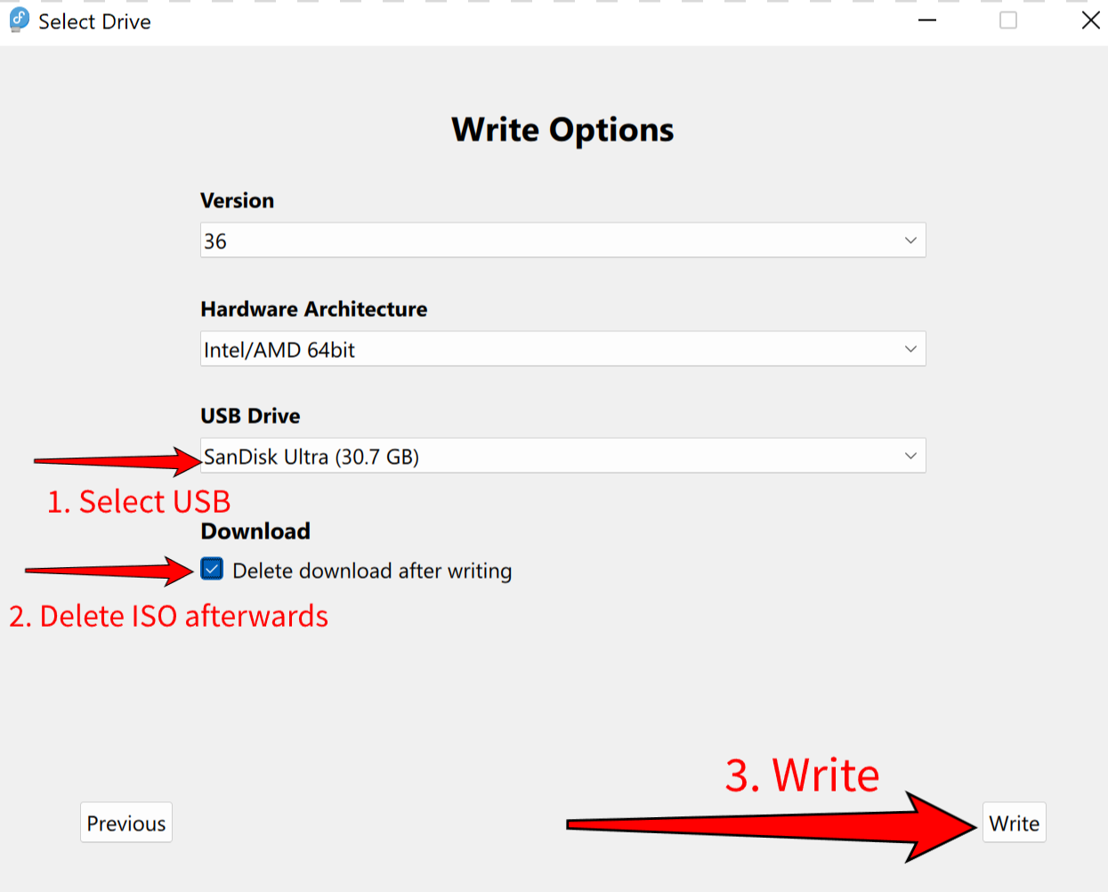
- You should see no error message and click “Finish”. You are good to go!
- (P.S. if there’s any error message, please contact the Linux Support Officer)

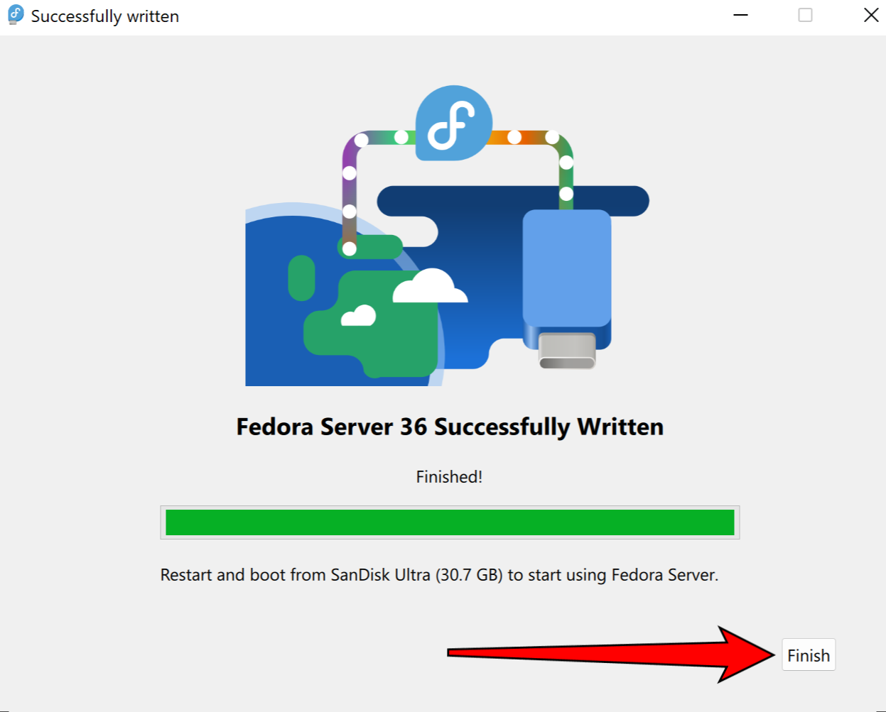

Step 3. Entering the boot session (In short)
- Reboot your PC
- Press Del and wait for a menu to pop up, then select your USB as a boot device.
- If 2. is not working, please follow 4.
- Press to enter the boot session and select your USB as the first boot loading device
If there are any difficulties getting the USB to boot, check out the link below for getting into the Boot Menu;
Regular Desktop:
https://www.youtube.com/watch?v=wH9q3KSISvQ
Apple Computer:
https://www.youtube.com/watch?v=XJDwF1BY66Y
Step 4. You should then see the follow screen. Select the language you want to use. Then click on the “Continue” Button in the bottom-right corner.
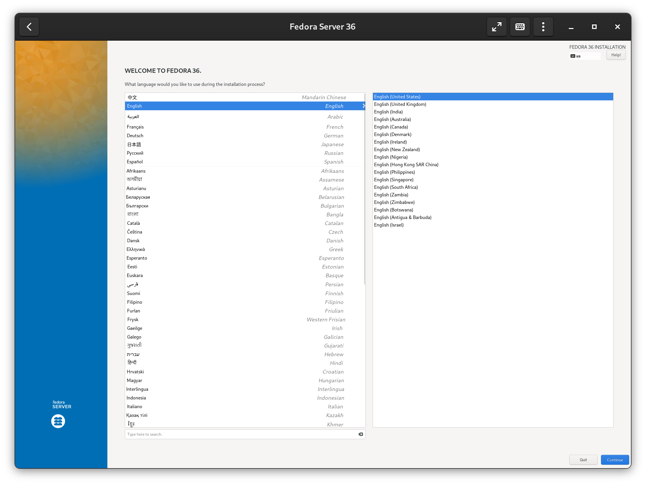
Step 5. Select the installation Destination as pointed by the arrow.
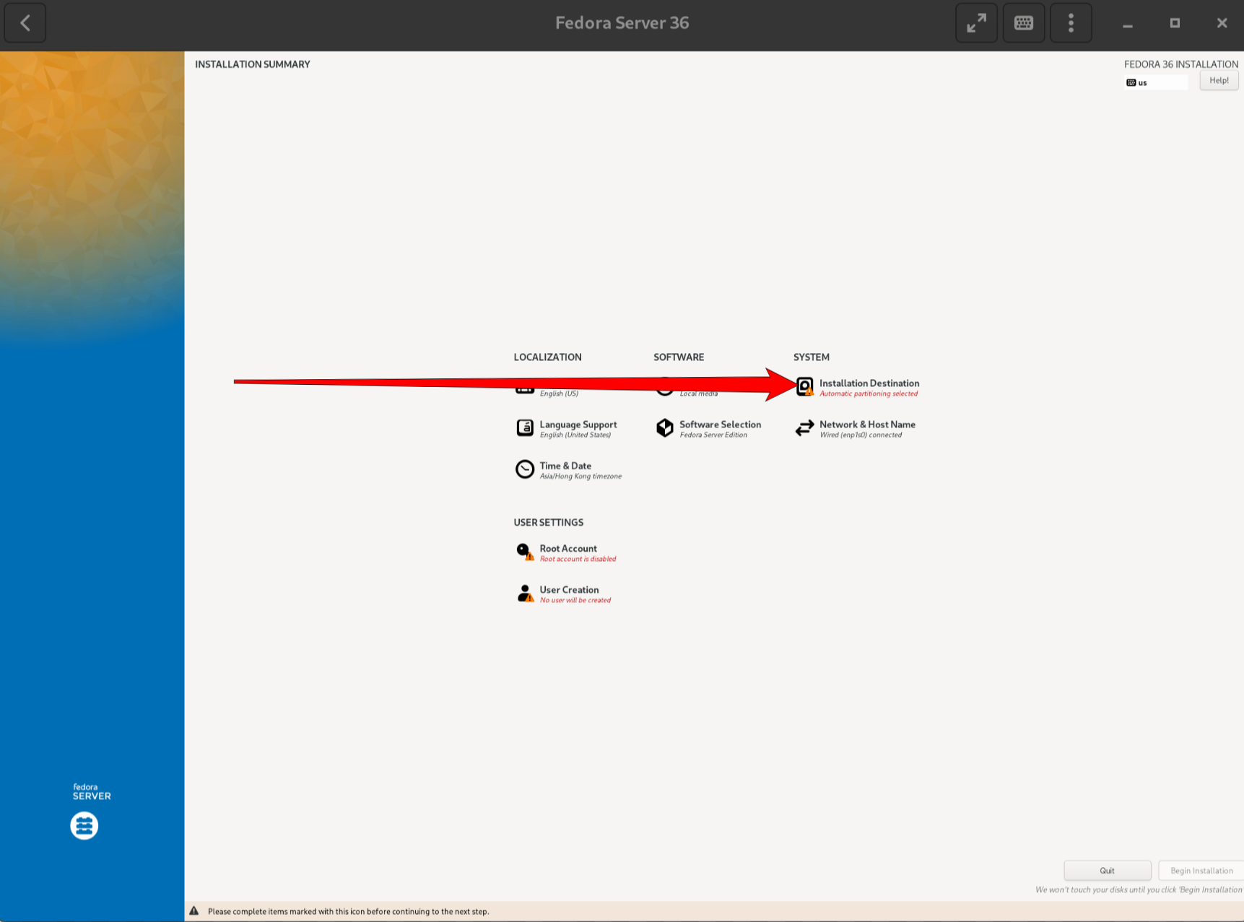
Step 6. You disk will be auto selected, if not, select the disk you would like to install the Fedora Server. Afterward, Click the “Done” Button as pointed.
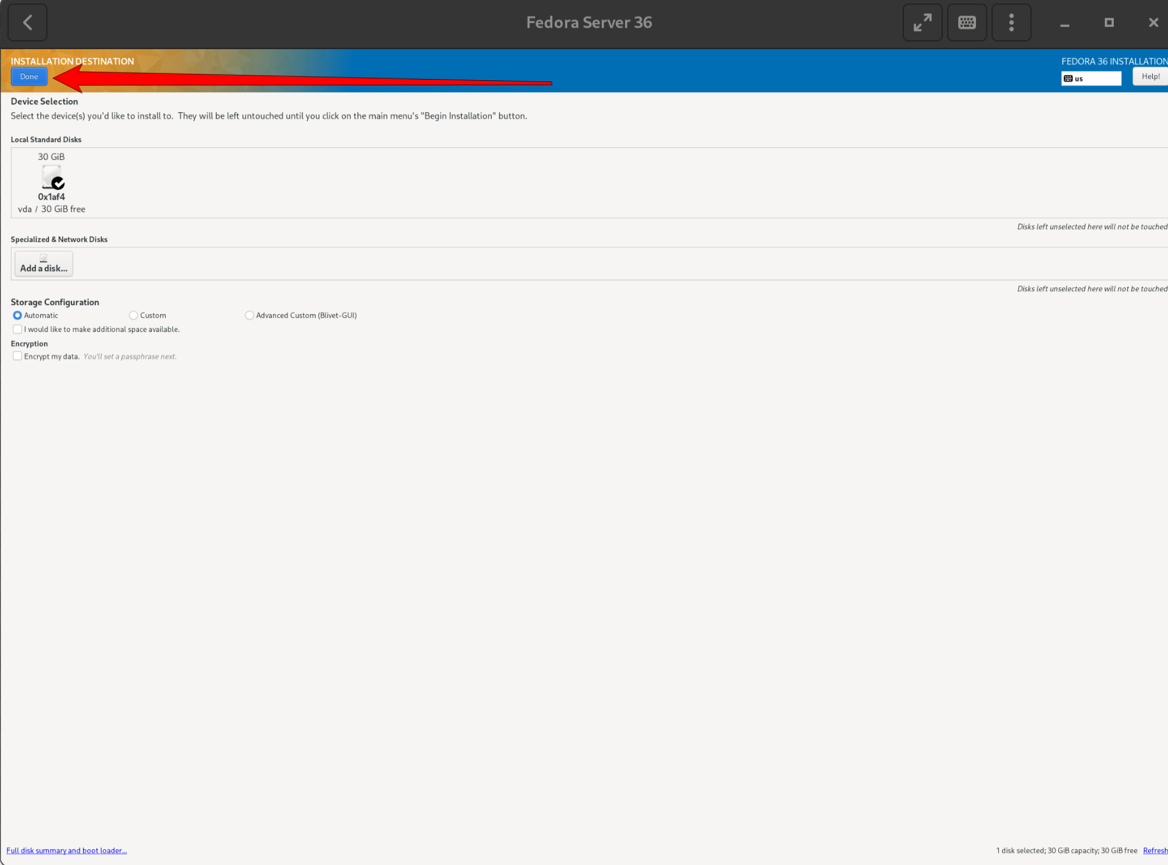
Step 7. Select the “Root Account”
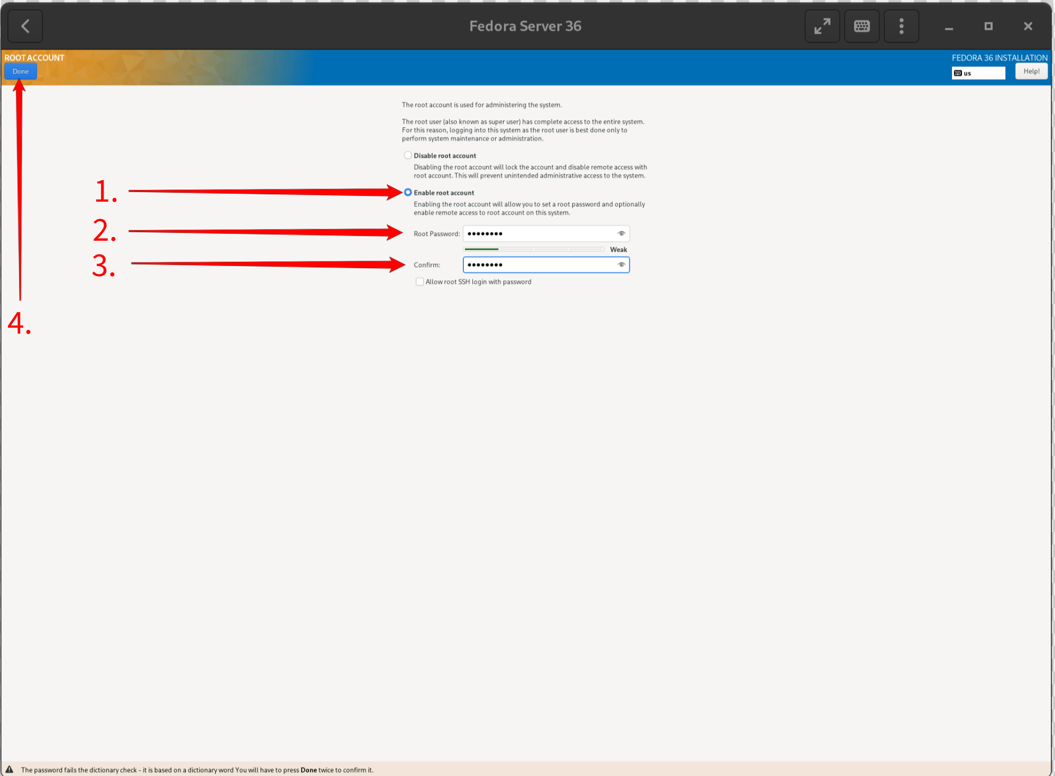
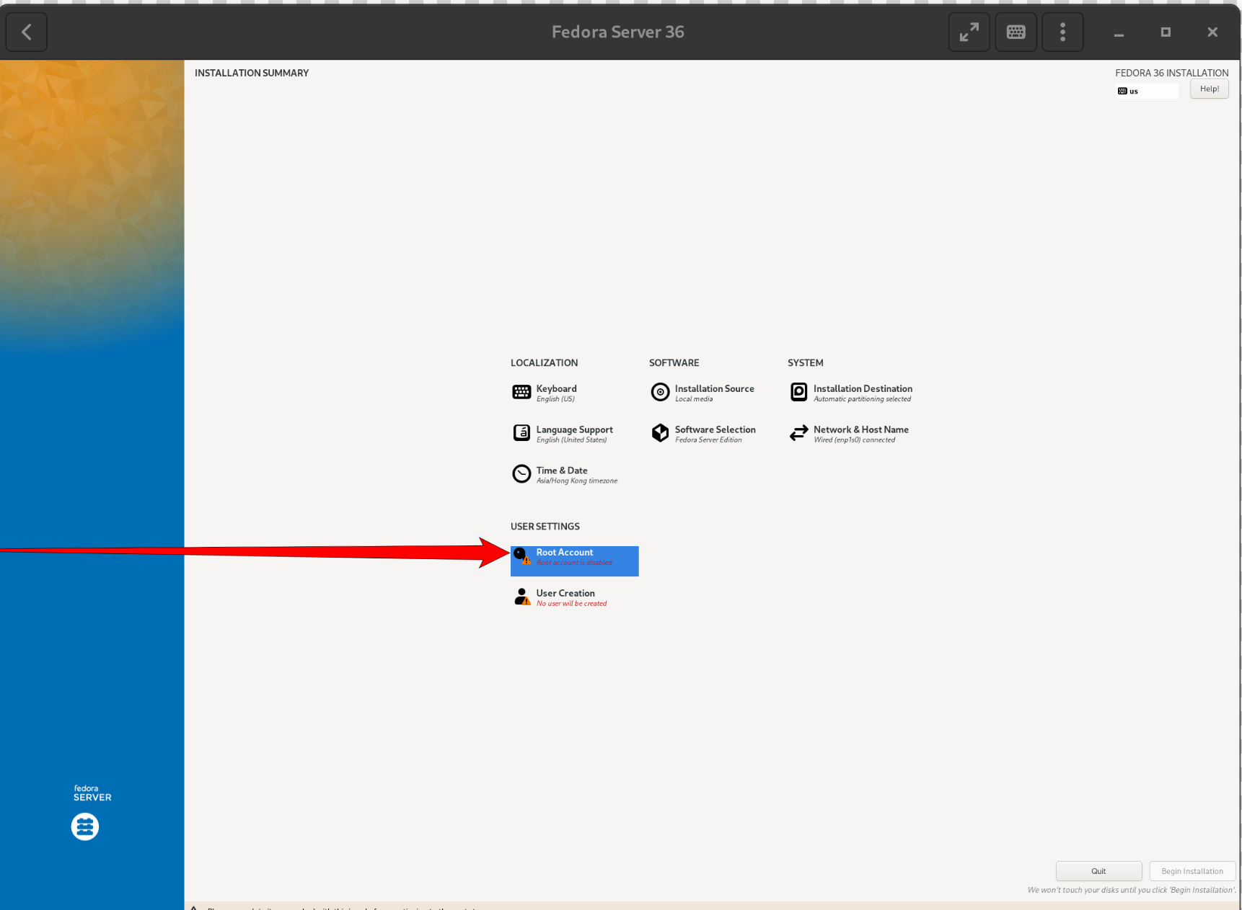
Step 8. Select “Enable root account” and enter your root password. At last, Click on the “Done” Button.
Step 9. Now select the “User Creation”
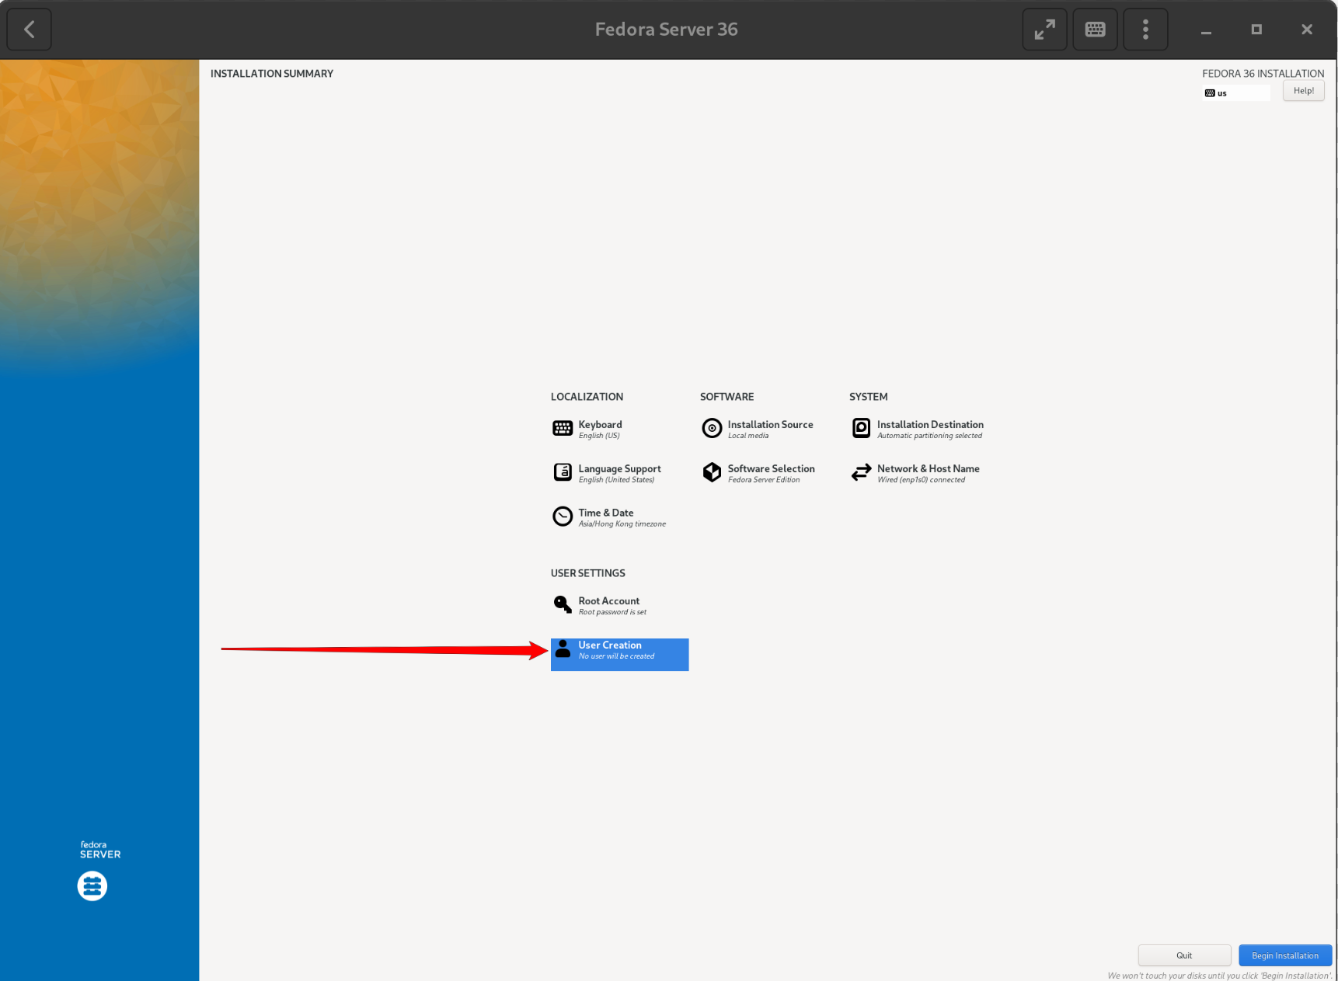
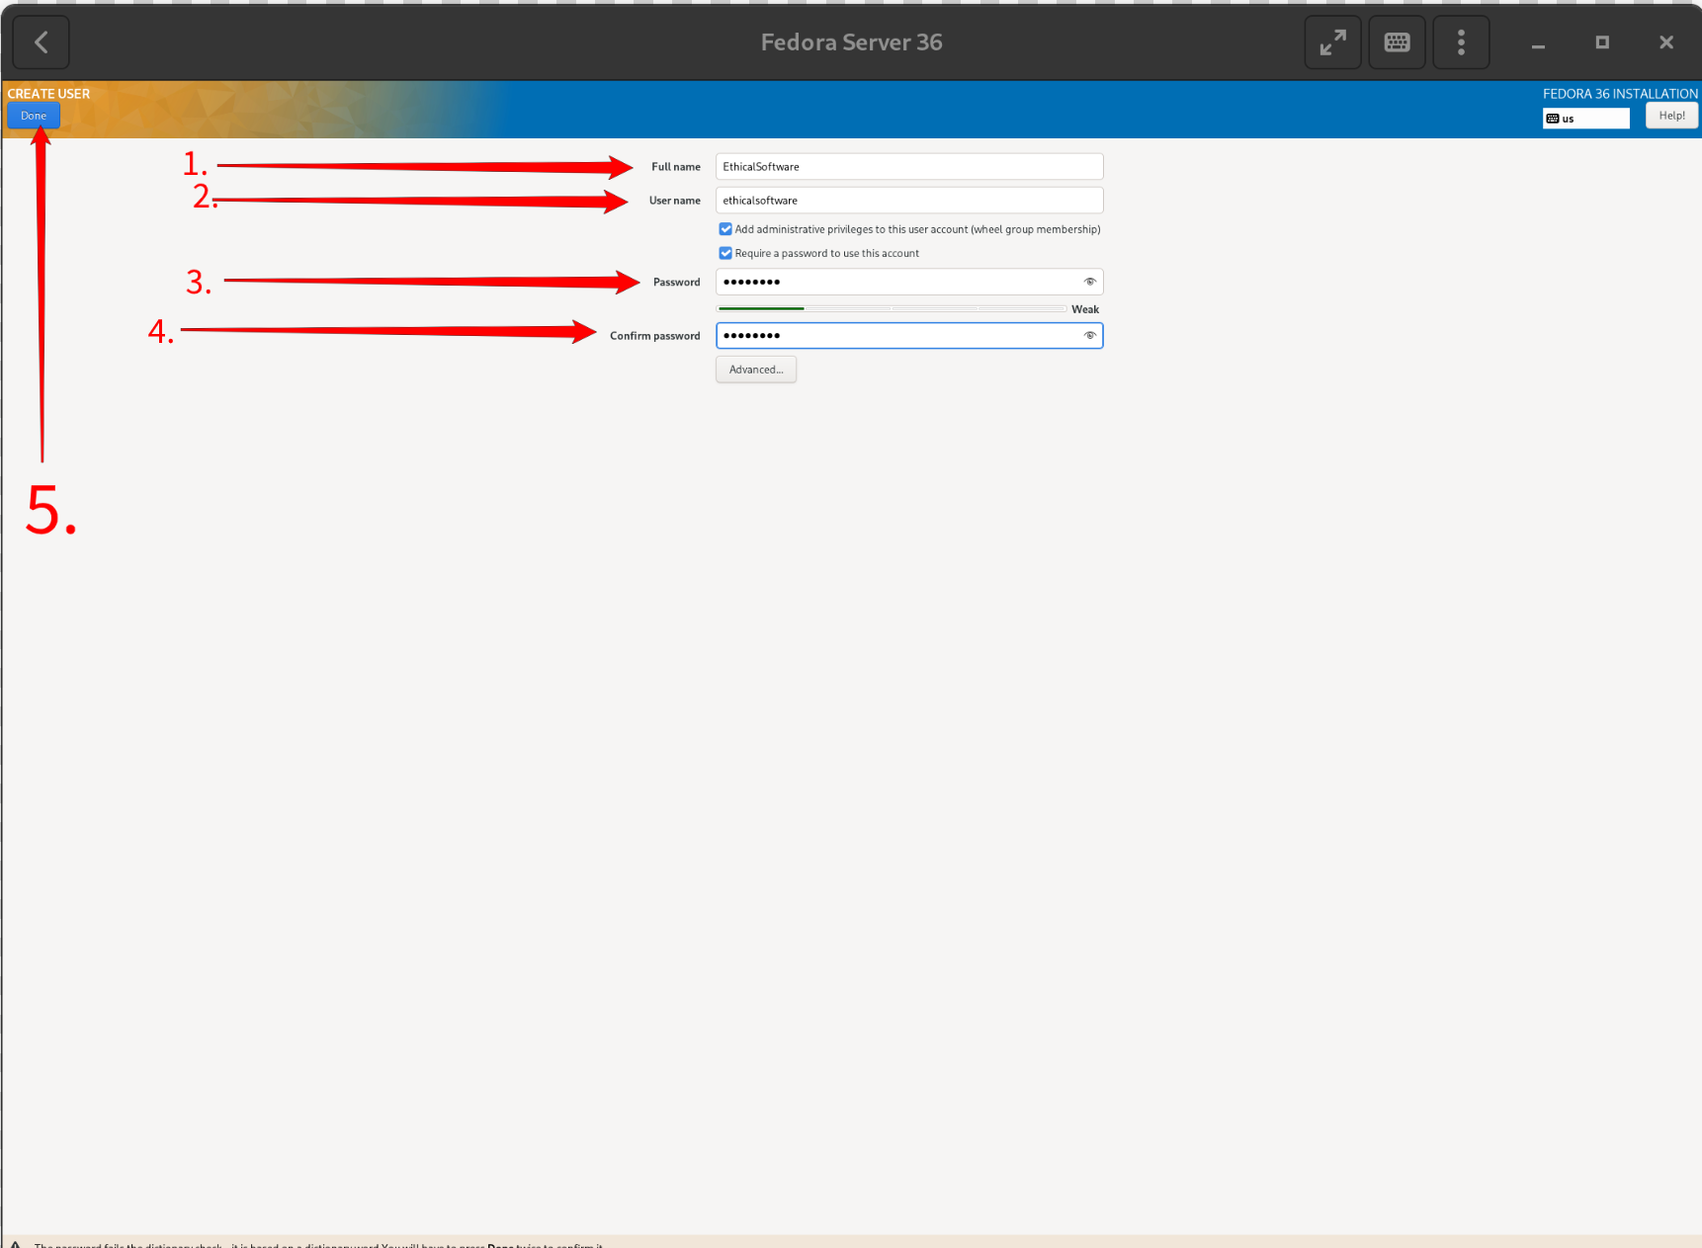
Step 10. Enter your Username and Password, then click “Done”
Step 11. Left Click on the “Begin installation” Button.
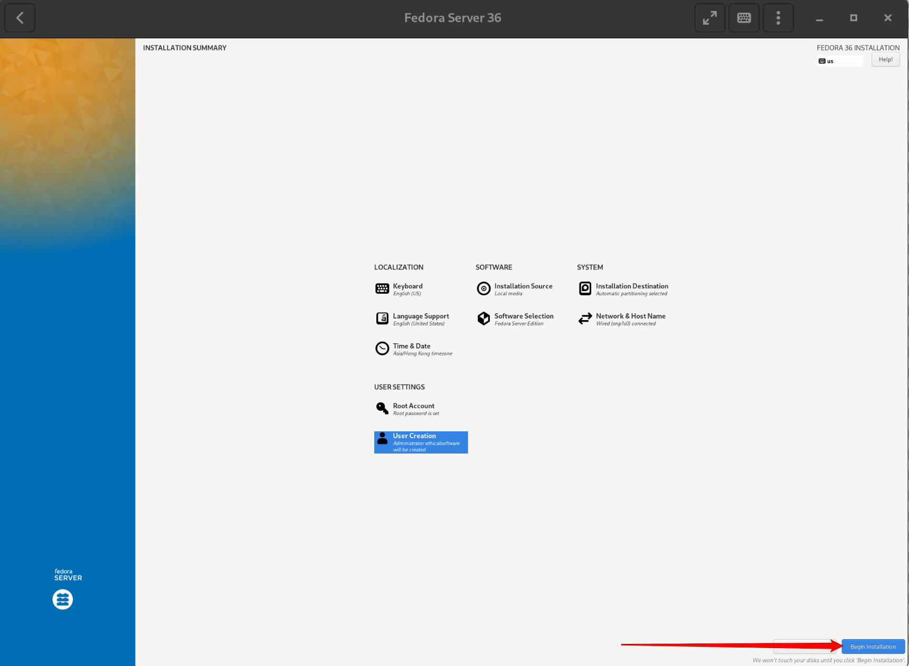
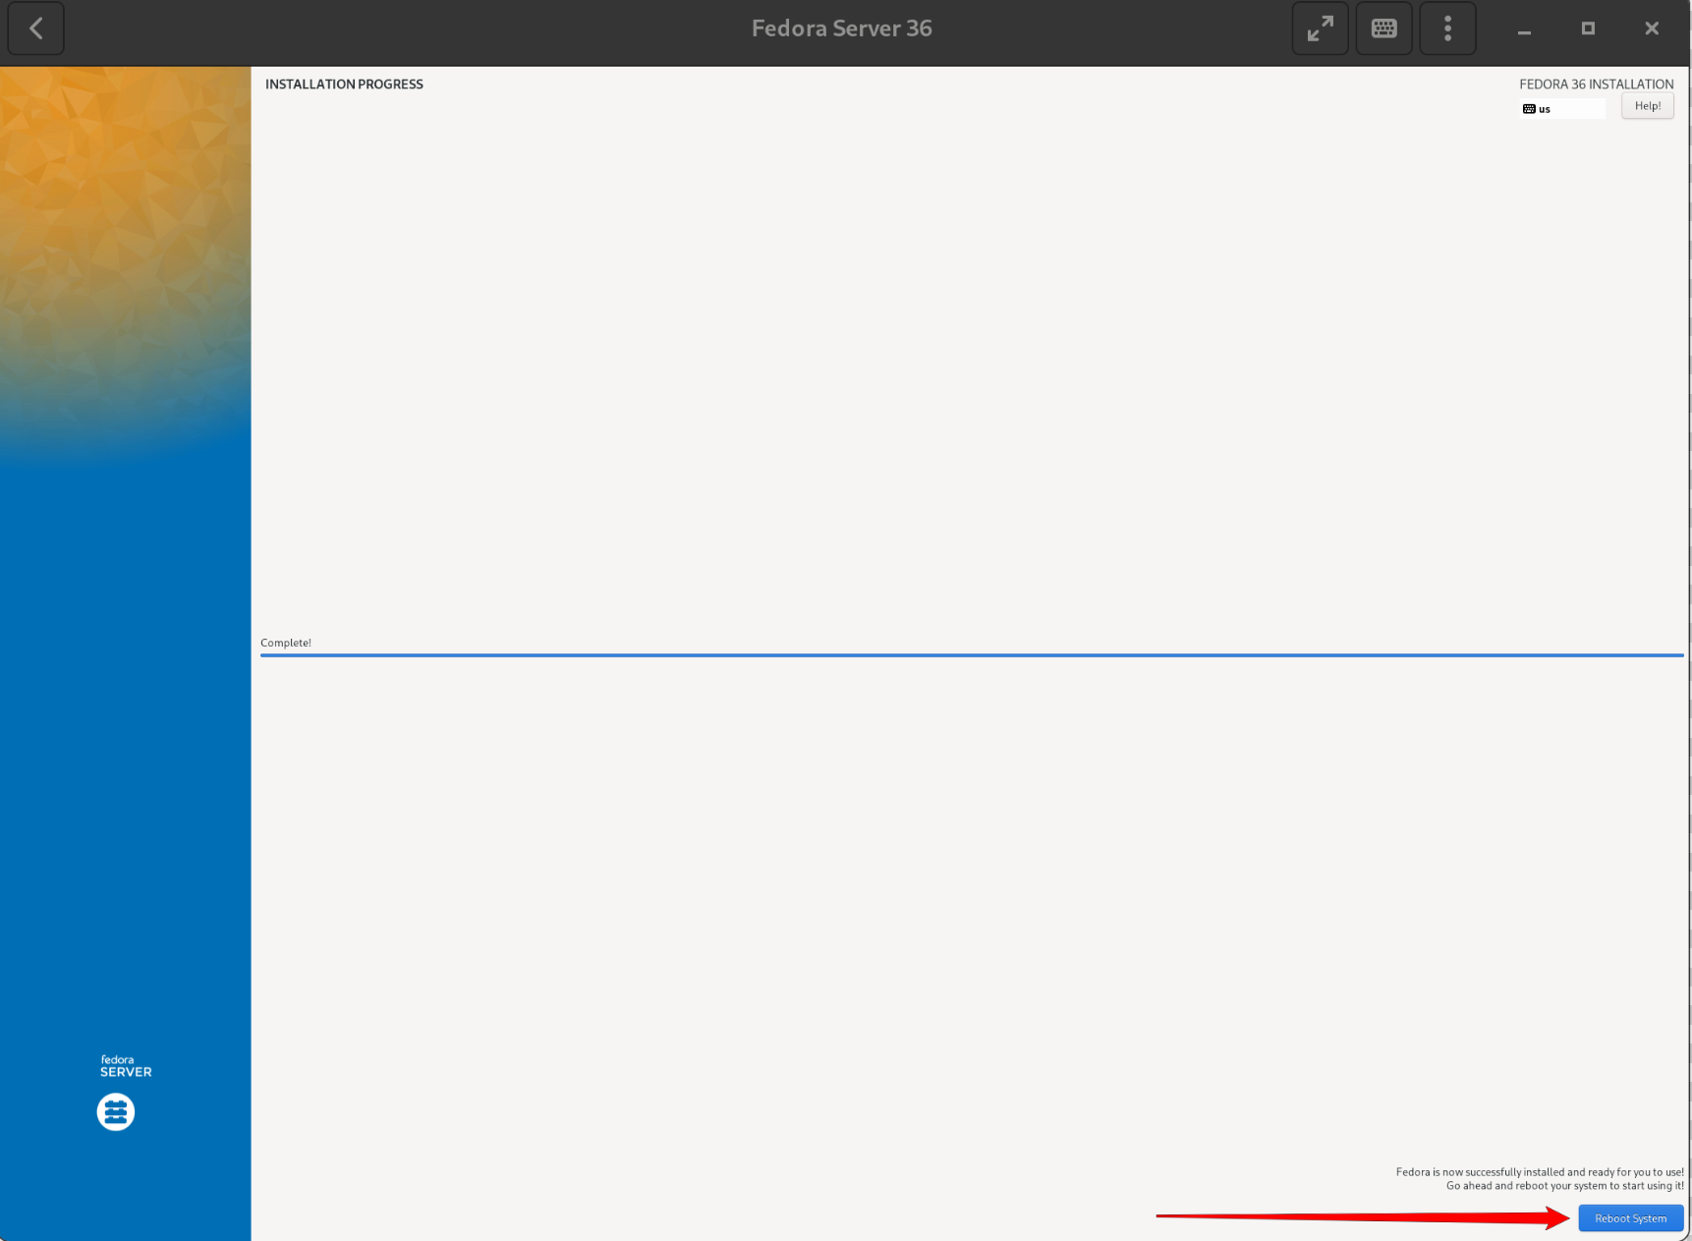
Step 12. After installation, Click “Reboot System”.
Step 13. After reboot, you should see the following screen, enter the “Username and password” you just configured in the setup screen.
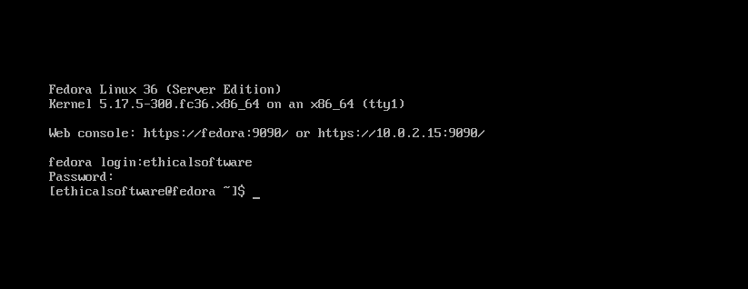
Step 14. Type the following command and enter your password:
If the ask for [y/N], enter “y”.
sudo dnf update

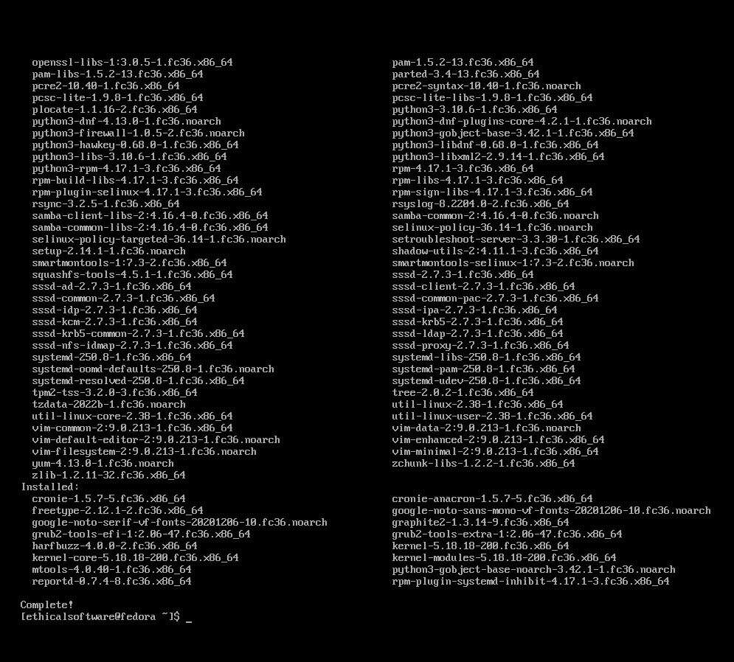

Step 15. Type the following command and enter your password:
sudo dnf -y group install "Basic Desktop" GNOME

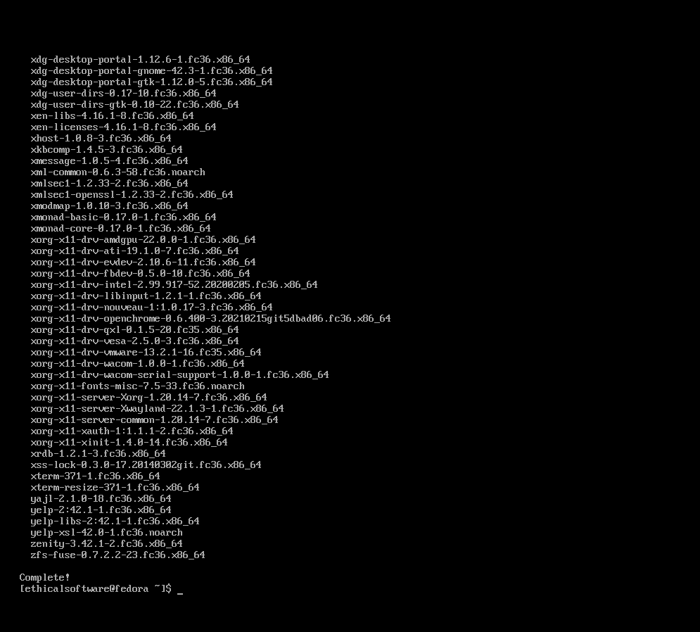

Step 16. Type the following command to set Gnome to Default and enter your password:
sudo systemctl set-default graphical.target
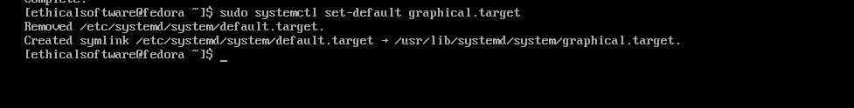
Step 17. Type the following command to restart your Server.
sudo reboot

Step 18. You should see the Gnome GUI, please enter your password to login. Then you are good to go.
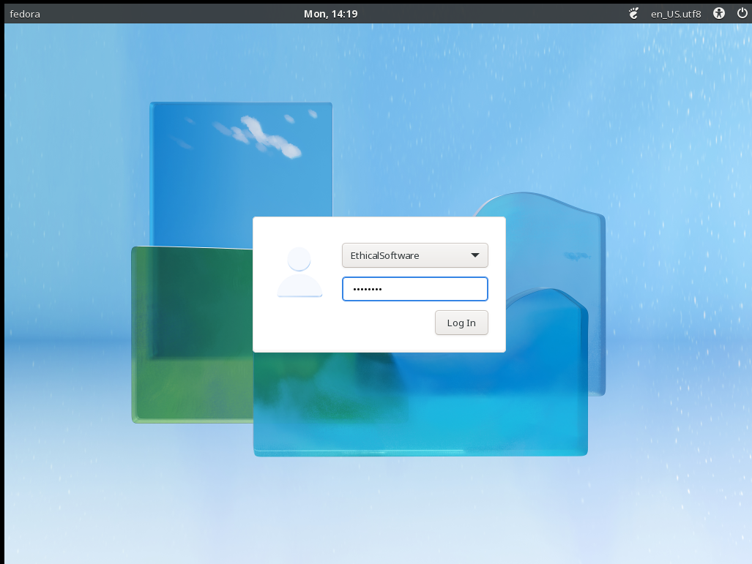
E.N.D

SSH

Enabling SSH in Fedora Server
Step 1. First, on your Fedora, move your mouse to the top-left corner of your screen.
You should see the following screen:

Example Output:

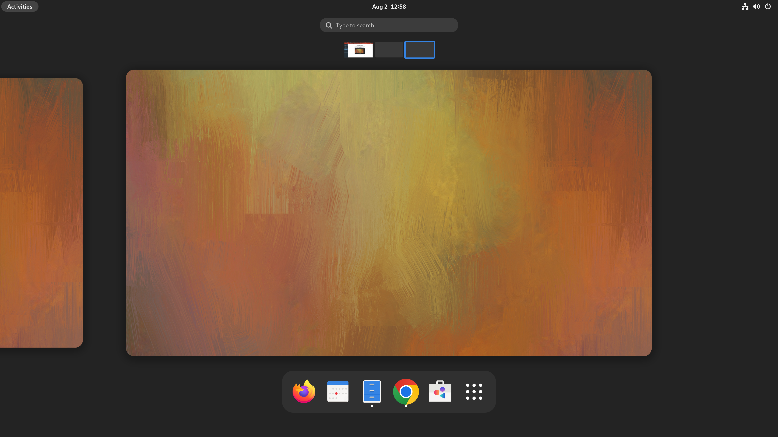

Step 2. Left Click “Type to search”.

Example Output:
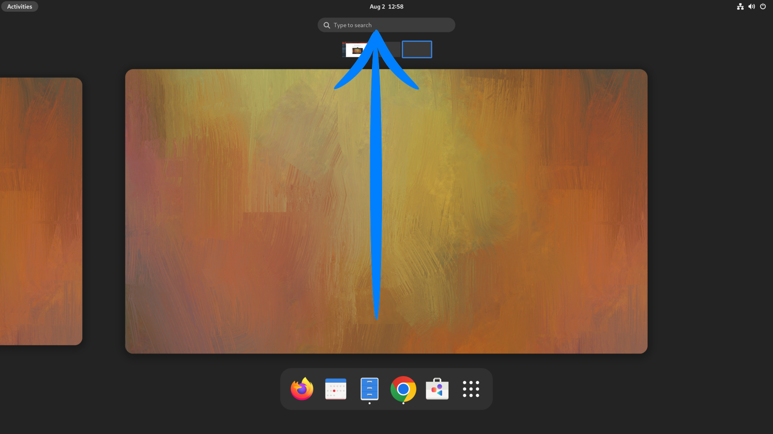
Step 3. Enter the word “ssh”. And click on the “Sharing” Option.
Example Output:
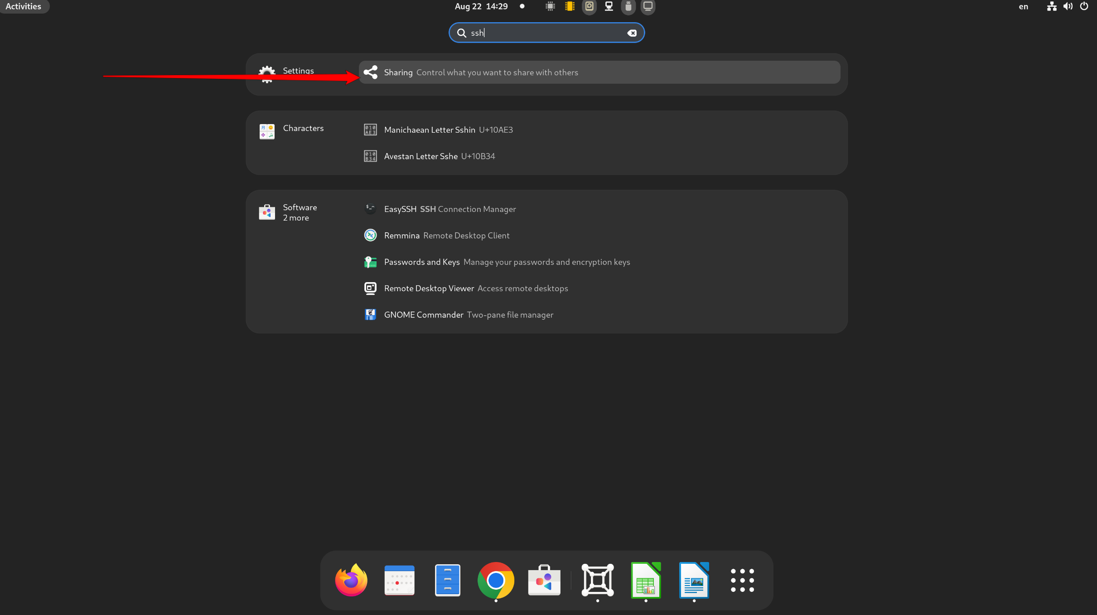
Step 4. Click on the “Sharing” Button and then go click on the Remote Login If it is “Off”.
Example Output:
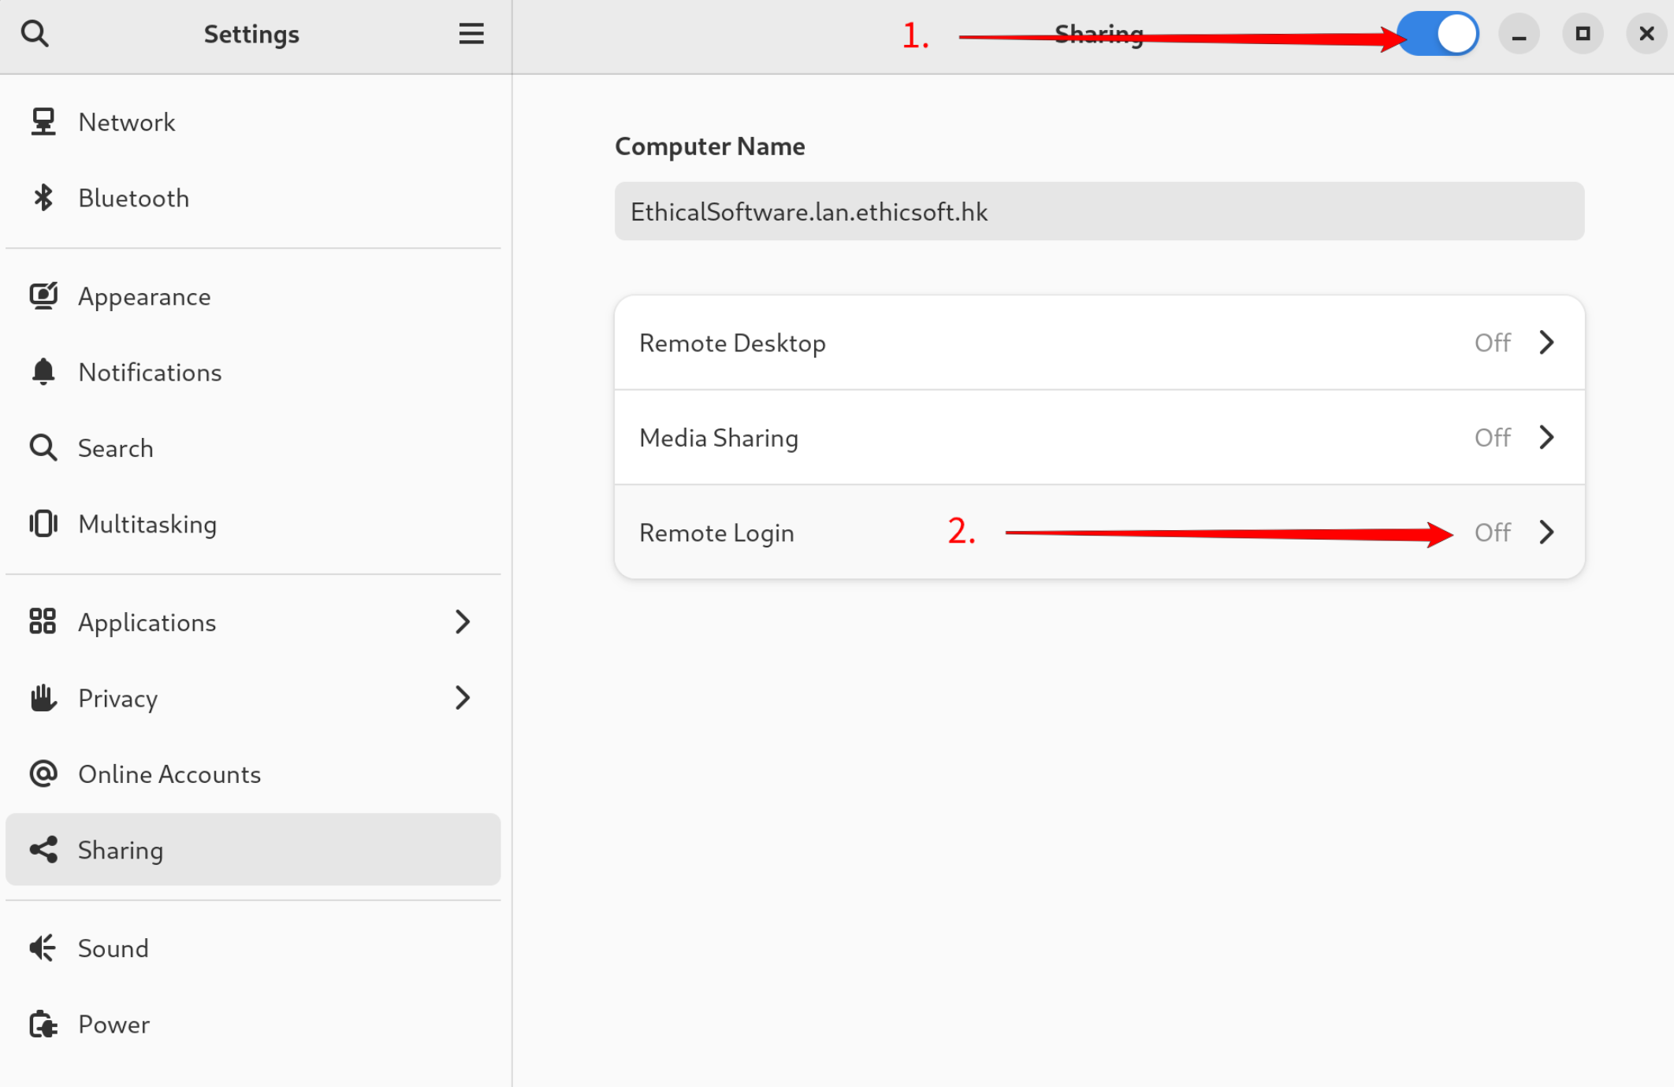
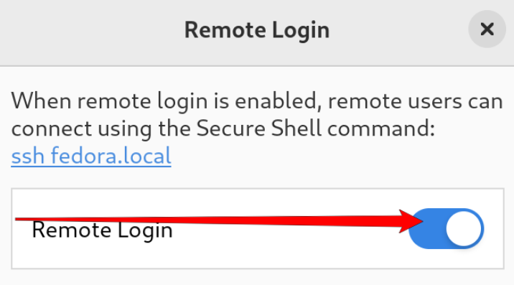
Step 5. Make sure you enabled the Button for “Remote Login”
Example Output:

Step 6. Repeat Step 1-3 but enter “Terminal” instead.
Example Output:
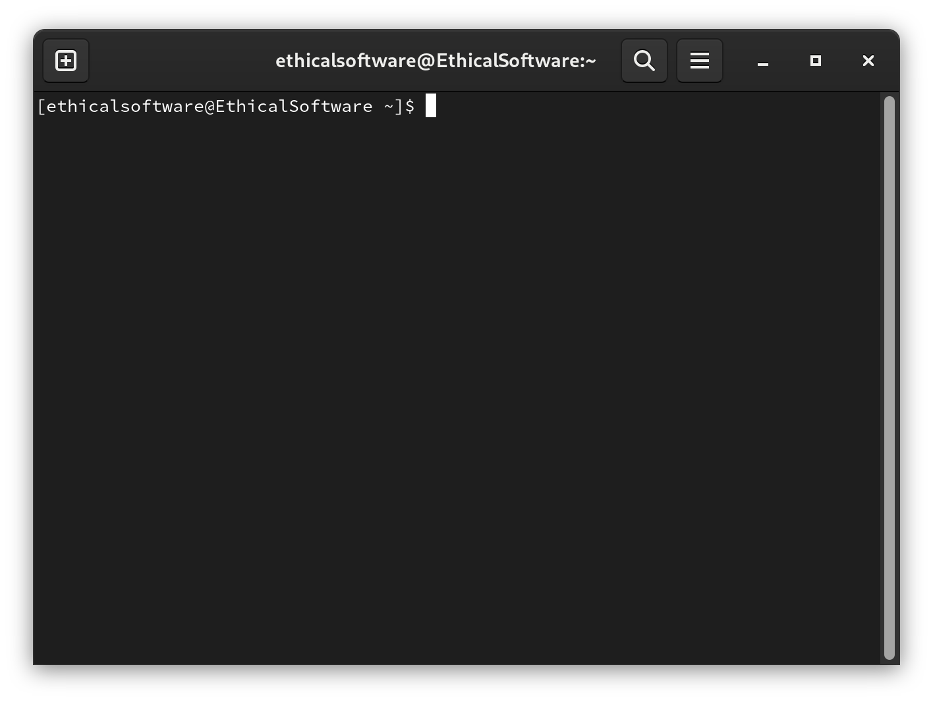
Step 7. Enter the command, you will find out your LAN IP address :
ifconfig
Example Output:
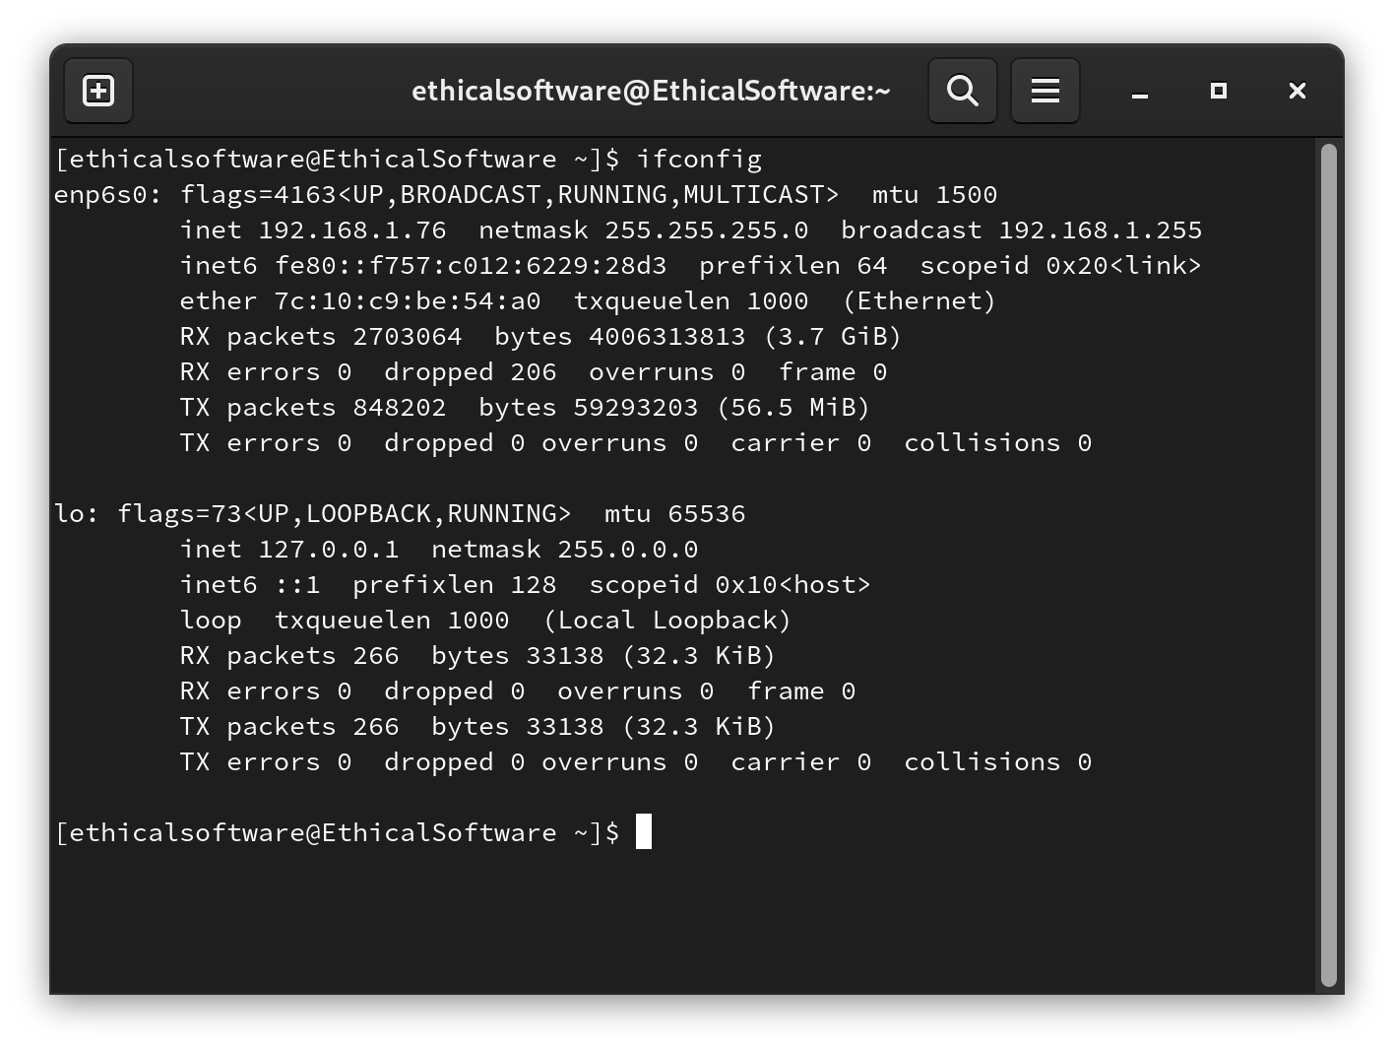

Step 8. Use another PC in your LAN, ssh connect it to the Fedora Server we created.
Enter the command and enter the ssh password:
ssh 192.168.1.76
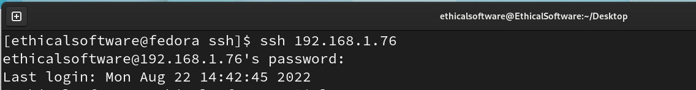
Example Output:

E.N.D

